**AIM-** To create a Cloud9 Environment.

**Theory-**Cloud9 IDE is an Online IDE, published as open source from version 2.0, until version 3.0. It supports multiple programming languages, including C, C++, PHP, Ruby, Perl, Python, JavaScript with Node.js, and Go. It is written almost entirely in JavaScript, and uses Node.js on the back-end.

***STEPS-***

LOG IN TO YOUR AWS ACCOUNT,

SEARCH FOR CLOUD 9 IN THE SEARCH BAR

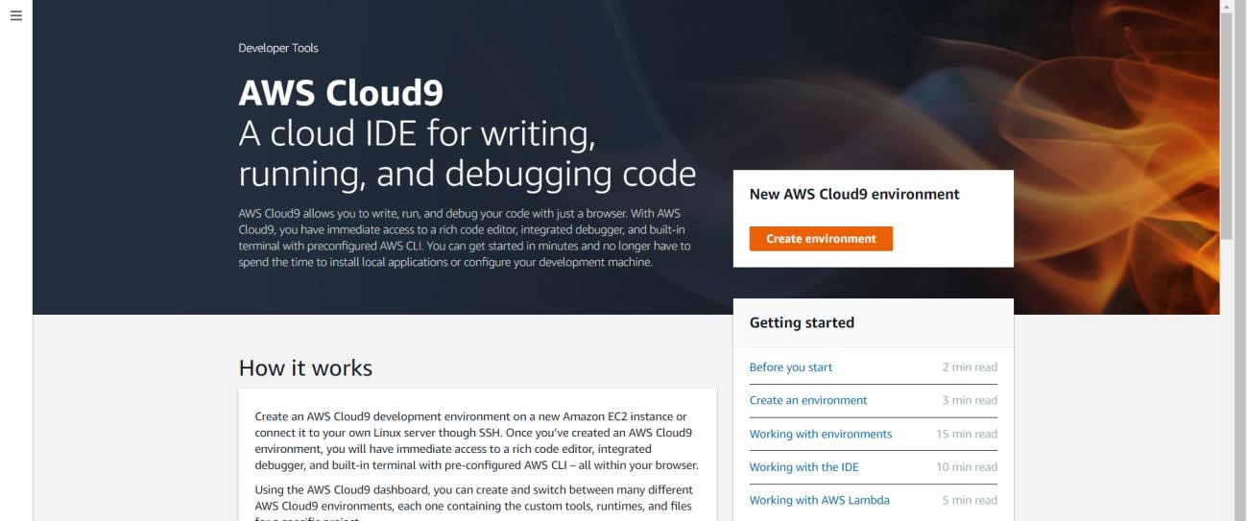

CLICK ON CREATE ENVIRONMNET,

NAME THE ENVIRONMNET

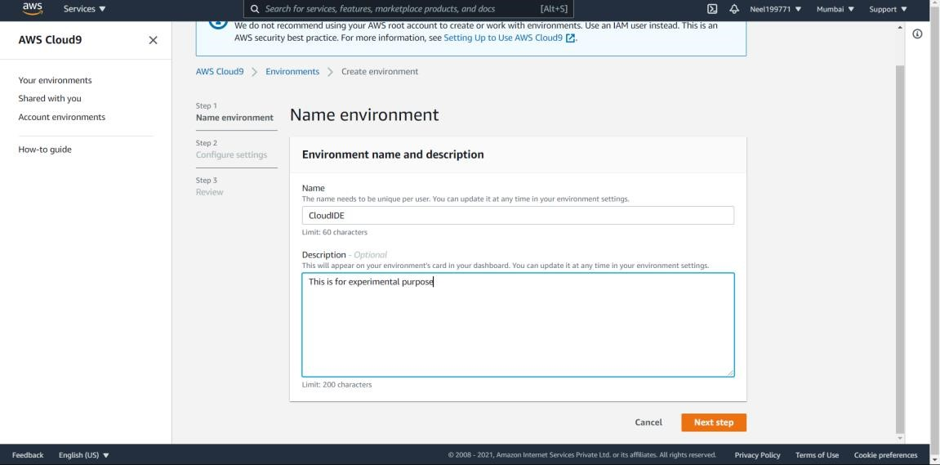

Now click on next step.

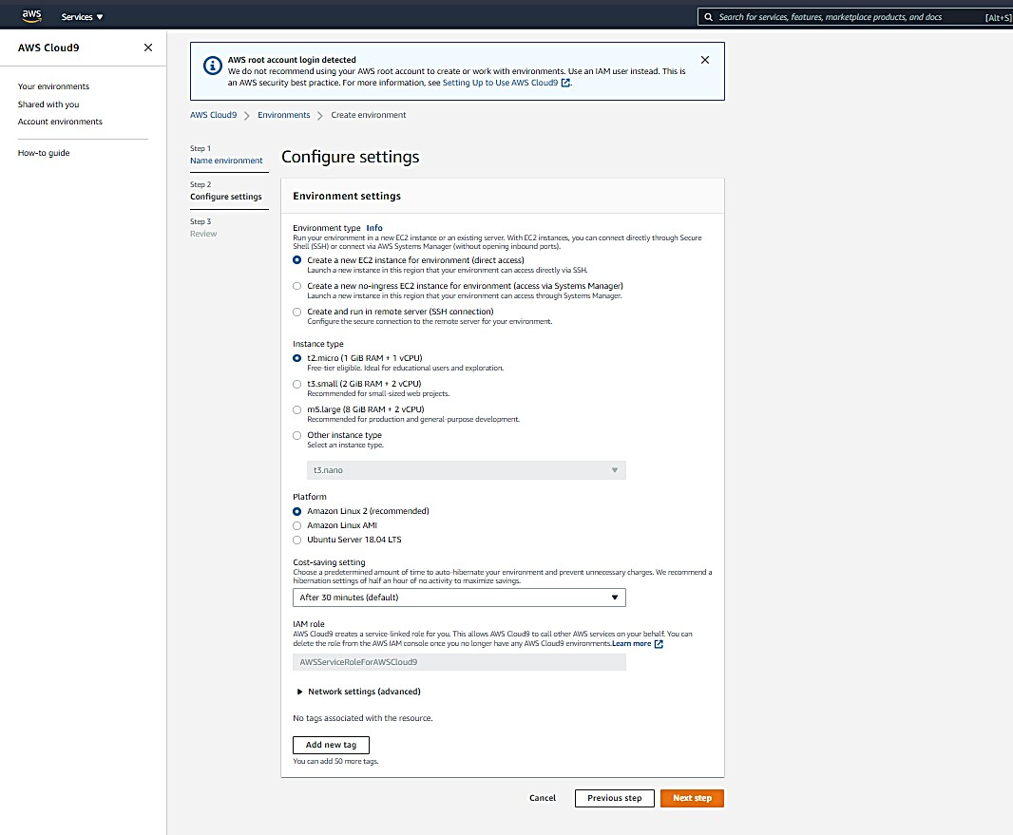

Again, click on Next Step,

Now click on Create Environment.

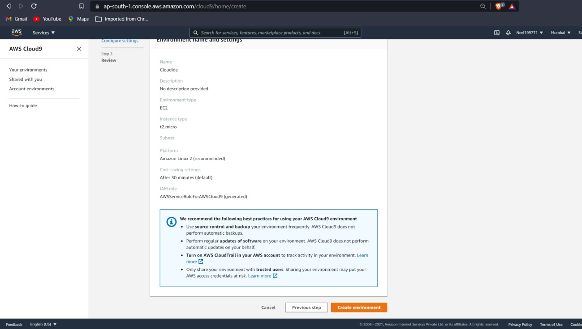

Now select any coding language and perform any operation via a code. Shown below

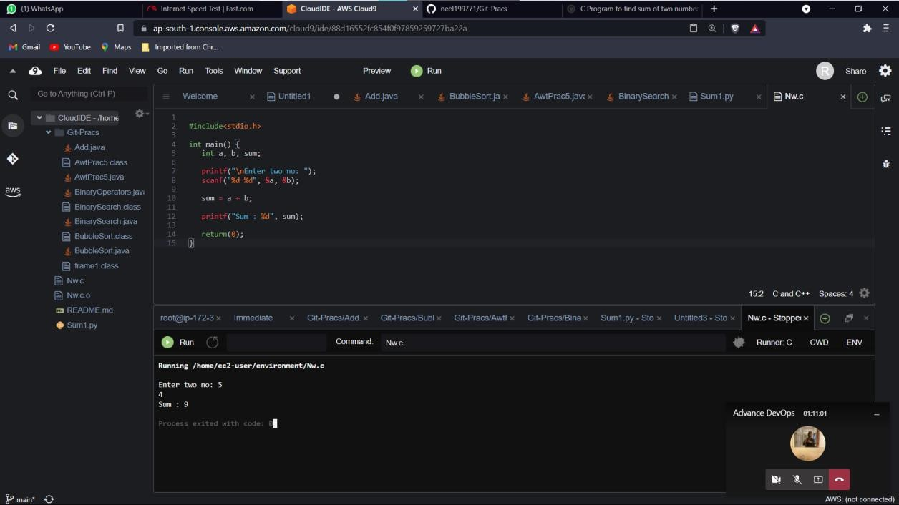

4

**ADVANCE DEVOPS LAB -2**

**CLOUD9**

***Conclusion –*** Hence learned and implemented steps to Create an Cloud9 environment.